**Superstore Sale Analysis Project – Power BI**

**CONTENTS**

* **Introduction**

* **Data Analytics**
* Power BI

* **Dataset of the project**
* Power BI Analysis
* Visualizations
* Clustered Bar Chart
* Clustered Column Chart
* Line & Stacked Column Chart
* 100% Stacked Column Chart
* Map – Geographical Analysis
* Pie Chart
* Donut Chart
* Tables
* Image
* **Data Cleansing**
* Cleaning steps
* **Analysis of the dataset**

1. What are total sales and total profits of each year?
2. What are the total profits and total sales per quarter?
3. What region generates the highest sales and profits?
4. What state and city brings in the highest sales and profits?
5. The relationship between discount and sales and the total discount per category
6. What category generates the highest sales and profits in each region and state?
7. What are the names of the products that are the most and least profitable to us?
8. What segment makes the most of our profits and sales?
9. How many customers do we have (unique customer IDs) in total and how much per region and state?
10. Customer rewards program
11. Average shipping time per class and in total

* **Implementation Phase**
* **Dashboard**
* **Conclusion**

**Introduction**

## ****What Is Superstore?****

A **superstore** is a large store traditionally aimed at meeting consumers' total needs for routinely purchased food products, non-food items, and services.

**Superstores** are large-scale retail establishments designed to meet consumers' comprehensive needs under a single roof.

They go beyond the traditional supermarket model by offering an extensive range of products and services. With their expansive layouts and diverse offerings, superstores aim to provide convenience and efficiency to shoppers.

## ****Understanding the Superstore****

Superstores have revolutionized the retail industry by providing consumers with a one-stop shopping experience. They are mammoth-sized retail establishments designed to cater to the diverse needs of consumers. These retail giants take the concept of convenience to new heights by offering an extensive array of products and services, all housed within a single expansive space.

### ****Superstore Vs Supermarket****

While they may sound similar, there are distinct differences between the two.

**Superstore**

One of the key features of superstores is their extensive product selection. They go beyond the traditional [supermarket](https://the-definition.com/term/supermarket) model, offering more goods. You can find groceries, household essentials, electronics, clothing, home decor, furniture, and more.

The sheer size of superstores allows them to accommodate a greater variety of products, giving customers ample choices to suit their preferences.

**Supermarket**

On the other hand, supermarkets focus primarily on grocery shopping. While they may also carry a limited range of non-food items, their core emphasis is on providing customers with a well-stocked selection of food products. Supermarkets are typically smaller than superstores, with a layout that optimizes the shopping experience for grocery items.

## ****Advantages of Superstore****

Superstores have redefined how consumers shop by providing a comprehensive and convenient retail experience.

**Convenience**

Superstores are synonymous with convenience. They eliminate the need for customers to visit multiple stores to fulfil their shopping needs. By providing a comprehensive range of products and services, superstores save time and effort for consumers, who can find everything they require in one place. This aspect mainly benefits busy individuals and families seeking a streamlined shopping experience.

**Competitive Pricing**

The combination of grocery and non-food offerings in superstores often leads to cost savings for consumers. Supercenters, for instance, offer discounted non-food products alongside competitively priced groceries, making them an attractive option for budget-conscious shoppers. Moreover, category killers frequently leverage their specialized market dominance to negotiate favorable prices with suppliers, passing on the savings to customers.

**Extensive Product Selection**

Superstores excel in providing an unparalleled selection of products. Their vast floor spaces allow for a broad assortment, enabling customers to choose from numerous brands, styles, and variants. Whether it's groceries, clothing, electronics, or household goods, superstores offer an extensive range of choices to cater to diverse consumer preferences.

**Enhanced Customer Experience**

Category killers set themselves apart by employing knowledgeable staff members well-versed in their respective product domains. These experts can guide customers through the available options, provide recommendations, and address queries effectively. Such personalized assistance enhances the overall customer experience, fostering loyalty and trust.

#### **Real-Life Example**

**Walmart Supercenter**

Walmart Supercenter is a prime example of a superstore that has revolutionized the retail industry. With its massive presence and comprehensive offerings, Walmart Supercenter has redefined the one-stop shopping concept. Walmart Supercenters are known for their competitive pricing, providing customers with cost savings on a wide range of products.

**What Is Data Analysis?**

Although many groups, organizations, and experts have different ways of approaching data analysis, most of them can be distilled into a one-size-fits-all definition. Data analysis is the process of cleaning, changing, and processing raw data and extracting actionable, relevant information that helps businesses make informed decisions. The procedure helps reduce the risks inherent in decision-making by providing useful insights and statistics, often presented in charts, images, tables, and graphs.

A simple example of data analysis can be seen whenever we make a decision in our daily lives by evaluating what has happened in the past or what will happen if we make that decision. Basically, this is the process of analyzing the past or future and making a decision based on that analysis.

It’s not uncommon to hear the term “[big data](https://www.simplilearn.com/tutorials/big-data-tutorial/what-is-big-data)” brought up in discussions about data analysis. Data analysis plays a crucial role in processing big data into useful information. Neophyte data analysts who want to dig deeper by revisiting big data fundamentals should go back to the basic question, “[What is data](https://www.simplilearn.com/what-is-data-article)?”

## Why is Data Analysis Important?

Here is a list of reasons why [data analysis](https://www.simplilearn.com/tutorials/data-analytics-tutorial/what-is-data-analytics) is crucial to doing business today.

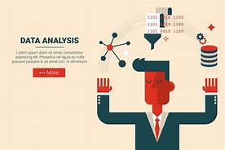

* Better Customer Targeting: You don’t want to waste your business’s precious time, resources, and money putting together advertising campaigns targeted at demographic groups that have little to no interest in the goods and services you offer. Data analysis helps you see where you should be focusing your advertising and marketing efforts.
* You Will Know Your Target Customers Better: Data analysis tracks how well your products and campaigns are performing within your target demographic. Through data analysis, your business can get a better idea of your target audience’s spending habits, disposable income, and most likely areas of interest. This data helps businesses set prices, determine the length of ad campaigns, and even help project the number of goods needed.
* Reduce Operational Costs: Data analysis shows you which areas in your business need more resources and money, and which areas are not producing and thus should be scaled back or eliminated outright.
* Better Problem-Solving Methods: Informed decisions are more likely to be successful decisions. Data provides businesses with information. You can see where this progression is leading. Data analysis helps businesses make the right choices and avoid costly pitfalls.
* You Get More Accurate Data: If you want to make informed decisions, you need data, but there’s more to it. The data in question must be accurate. Data analysis helps businesses acquire relevant, accurate information, suitable for developing future marketing strategies, business plans, and realigning the company’s vision or mission.

**Power BI**

**Microsoft Power BI** is a data visualization platform used primarily for business intelligence purposes. Designed to be used by business professionals with varying levels of data knowledge, Power BI’s dashboard is capable of reporting and visualizing data in a wide range of different styles, including graphs, maps, charts, scatter plots, and more. Power BI's "AI Insights" functionality, meanwhile, uses [artificial intelligence](https://www.coursera.org/articles/what-does-ai-stand-for) to find insights within data sets for users.

Power BI itself is composed of several interrelated applications: Power BI Desktop, Pro, Premium, Mobile, Embedded, and Report Server. While some of these applications are free-to-use, paid subscriptions to the pro and premium versions provide greater analytics capabilities.

### What is Power BI used for?

Whether you’re a data pro or are just entering the business world, Power BI is designed to empower you with data-driven insights. Some of the most common uses for the platform include:

* Creating reports and dashboards that present data sets in multiple ways using visuals
* Connecting various data sources, such as Excel sheets, onsite [data warehouses](https://www.coursera.org/articles/data-warehouse), and cloud-based data storage, and then transforming them into business insights
* Turning data into a wide range of different visuals, including pie charts, decomposition trees, gauge charts, KPIs, combo charts, bar and column charts, and ribbon charts – among many other options
* Providing company-wide access to data, data visualization tools, and insights in order to create a data-driven work culture

**ANALYSIS**

**Importing and Cleaning of dataset**

Initially, we identify the type of data we are working with, such as Excel data, SQL Server data, web data, or Power BI datasets. Once determined, we proceed to load and transform the data, initiating the cleaning process as the first step**.**

**There are some steps we use to clean data in Power BI, which are helpful in creating meaningful insights.**

1. Use the first row as a header.
2. Remove duplicate rows.
3. Remove duplicate and null columns.
4. Remove blank rows.
5. Check for null and blank values; if they exist, delete them.
6. Check data types; always convert numerical values into decimal or fixed decimal values.
7. Check date data types and convert them into the US and UK time zones using their respective locales.

**Here, I commence the cleaning process for Superstore Sales data. The initial steps include:**

1. Removing duplicate and blank rows.
2. Checking for null and blank values and deleting them if they exist.
3. Converting the data types of each column; numerical values to decimals & fixed decimal, and dates are adjusted to their local zones, such as US and UK.

**Following these steps, I close and apply the transformed dataset, where I proceed to conduct insightful analyses.**

**Requirement Analysis:-**

**Basic Charts:**

Bar Chart: Displays data using rectangular bars of varying lengths.

Column Chart: Similar to a bar chart but with vertical columns.

Line Chart: Represents data points with markers connected by lines.

**2. Advanced Charts:**

Area Chart: Similar to a line chart but with the area below the line filled.

Scatter Plot: Displays individual data points on a two-dimensional graph.

Waterfall Chart: Illustrates incremental positive and negative values that lead to a final total.

**3. Matrix and Tables:**

Matrix: Allows users to display data in a grid format with rows and columns.

Table: Presents data in a tabular format with customizable columns.

**4. Maps:**

Map: Visualizes geographical data using maps with custom shapes or points.

Filled Map: Colours regions on a map based on the values associated with those regions.

**5. Gauges and Cards:**

Card: Displays a single value or metric.

Gauge: Represents a single value within a range, often used for KPIs.

**6. Funnel and Pyramid Charts:**

Funnel Chart: Illustrates stages in a process, showing values decreasing sequentially.

Pyramid Chart: Similar to a funnel chart but in the shape of a pyramid.

1. **Slicers and Filters:**

Slicer: Provides an interactive way to filter data across multiple visuals.

Filter Pane: Allows users to apply filters to visuals using a filter pane on the report canvas.

1. **Custom Visuals:**

Users can import and use custom visualizations created by the Power BI community or develop their own using the Power BI developer tools.

**10. Combo Charts:**

Combines multiple chart types on a single visual for more comprehensive insights.

**11. Tree maps and Sunburst Charts:**

Tree map: Displays hierarchical data as nested rectangles.

Sunburst Chart: Visualizes hierarchical data in a radial layout.

**12. Time-Series Visualizations:**

Line Chart with Time Axis: Ideal for visualizing trends over time.

Timeline Slicer: Provides an interactive timeline to filter data.

**13. Statistical and Analytical Visualizations:**

Box and Whisker Plot: Displays statistical information about the distribution of data.

Scatter Plot Matrix: Shows scatter plots for multiple variables.

**14. Custom Tooltip and Formatting:**

Customize tooltips to display additional information.

Adjust formatting options to enhance the appearance of visualization. What are the total profits and total sales per quarter?

* 1. **What are the total profits and total sales per quarter?**

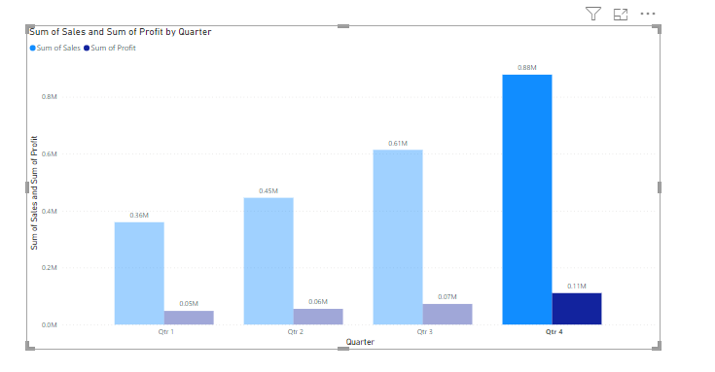

**Analysis:**

Firstly, input the sales and profits by quarter. Finally, observe the results to identify the sum of total profits and sum of total profit per quarter.

Hence, the result allows us to identify the total profits and total profit per quarter.

* 1. **What are total sales and total profits of each year?**

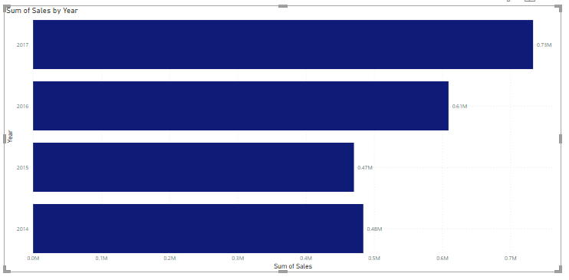

**Analysis:**

Here, input the sales and profits by year. Finally, observe the results to identify the sum of total profits and sum of total profit by year.

Hence, the result allows us to identify the total profits and total profit per year.

* 1. **What region generates the highest sales and profits?**

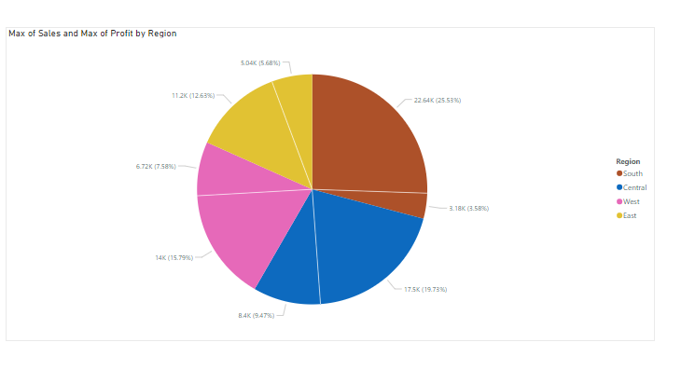

**Analysis:**

I used a stacked column chart with a column for the region, sales and identified the sum of sales and sum of profits by region.

* 1. **What state and city brings in the highest sales and profits?**

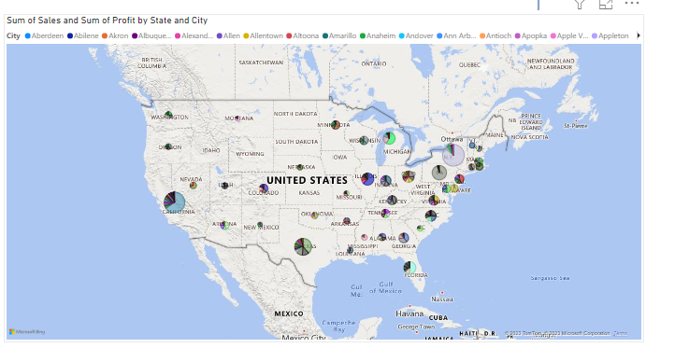

**Analysis:**

I used a Map with a column for city and states. I analyzed the sum of sales and sum of profit by state and city.

* 1. **The relationship between discount and sales and the total discount per category**

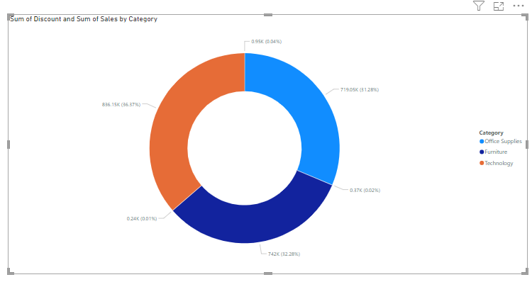

**Analysis:**

Here, we have a column for sales, category and the total discount. We identified the relationship between discount and sales and the total discount per category.

* 1. **What category generates the highest sales and profits in each region and state?**

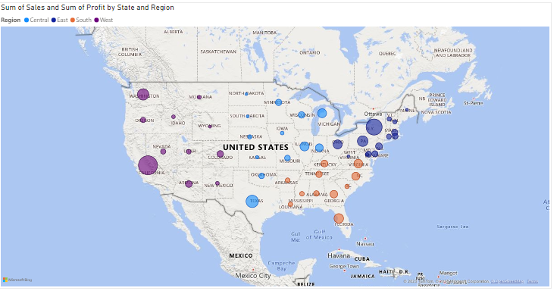

**Analysis:**

Here, I have columns for category, sales, profits and region, state and I identified the category generates the highest sales and profits in each region and state.

* + 1. **What are the names of the products that are the most and least profitable to us?**

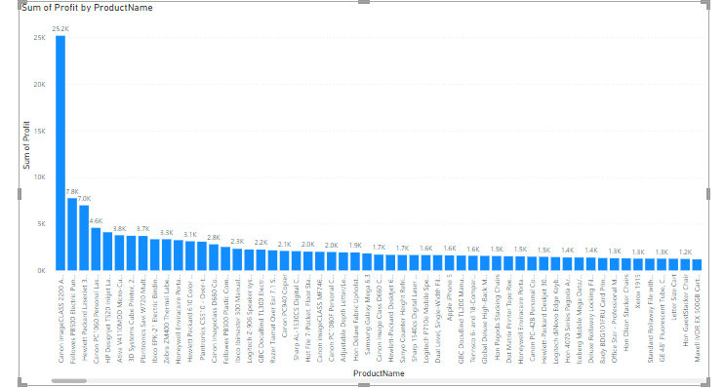

**Analysis:**

I used a clustered column chart with a column for products and profit. I analyzed the names of the products are most profitable.

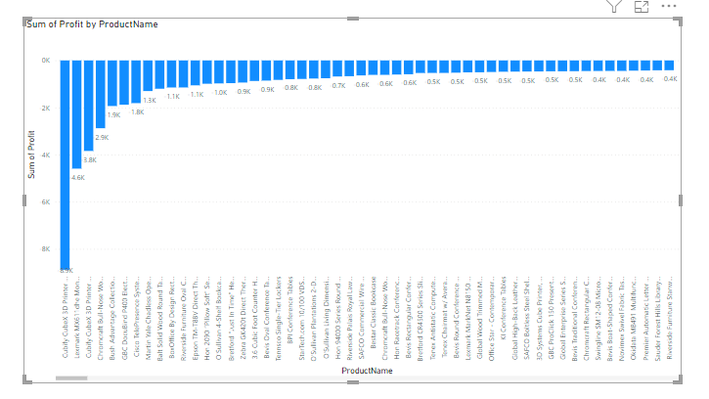

**Analysis:**

I used a clustered column chart with a column for products and profit. I analyzed the names of the products are least profitable.

**8. What segment makes the most of our profits and sales?**

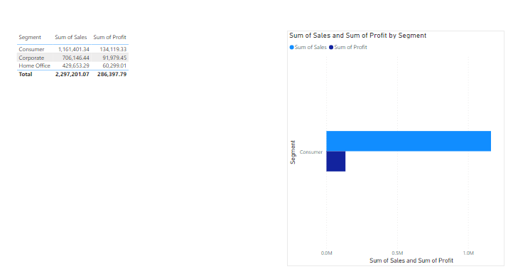

**Analysis:**

Firstly, input the sum of sales or profit and the segment. Next, apply basic filtering by selecting the "Top N" option and entering the value 1. Then, drag the sum of profit into the designated area. Finally, observe the results to identify the segment is most of our sales and profit.

* + 1. **How many customers do we have (unique customer IDs) in total and how much per region and state?**

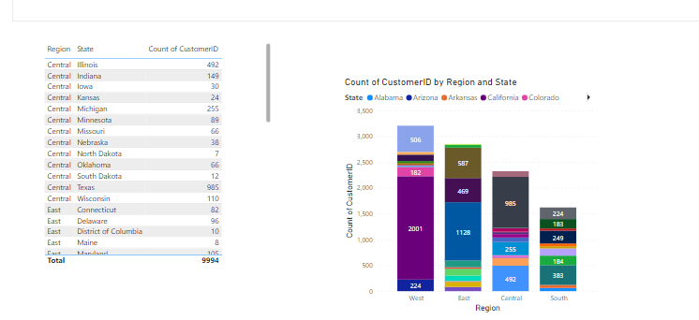

**Analysis:**

Here, initially capturing data on states, regions. Within the available columns, I sought to identify the unique customer IDs where the majority of unique customers IDs in per states and also its regions.

* + 1. **Customer rewards program**

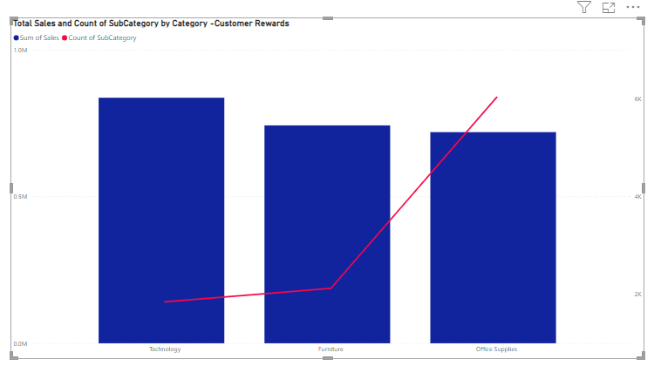

**Analysis:**

Here, initially capturing data on category, subcategory and total sales. Within the available columns, I sought to identify the customers are rewarded based on the occurrence of the highest sales in their respective category.

* + 1. **Average shipping time per class and in total**

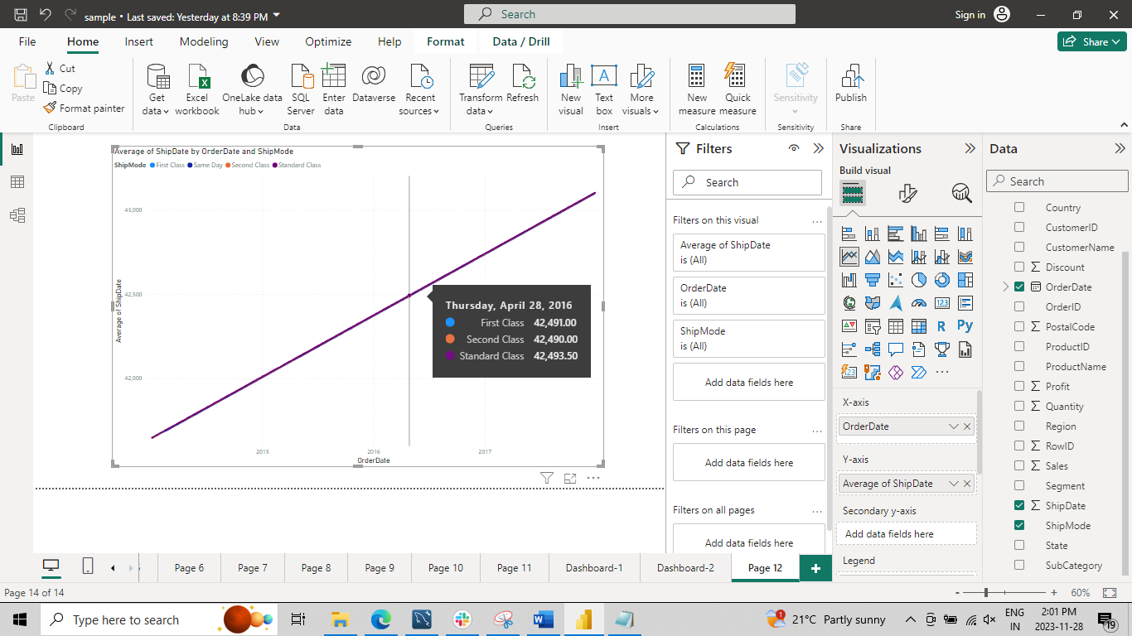

**Analysis:**

Here, Initially, I calculated the average duration between the order date and ship date for each ship mode. Among the available columns, I aimed to determine the average shipping time per class, and I presented it as part of the analysis.

**Dashboard**

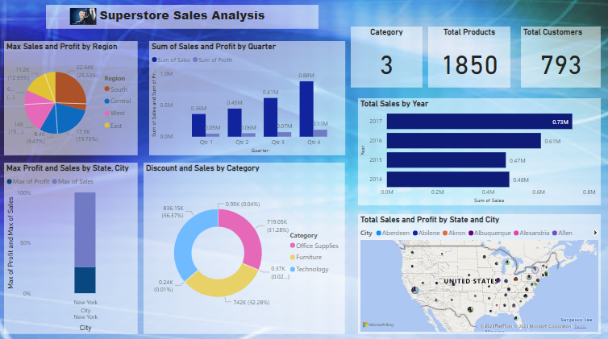

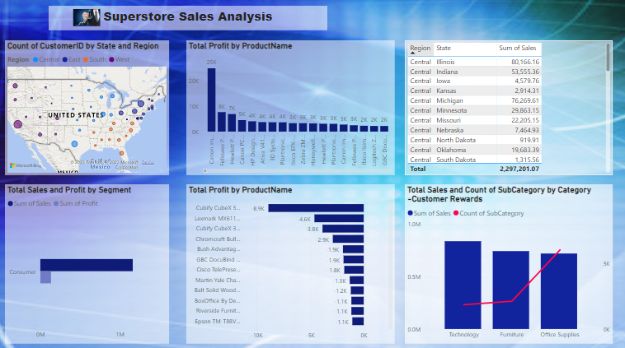

* **Conclusion**

Trends in Total Sales and Profits:

Identify trends in total sales and profits over the years to understand the overall business performance. Finally, observe the results to identify the sum of total profits and the sum of total profit by year.

Quarterly Performance:

Analyze total profits and sales per quarter to identify any seasonality or specific periods of high/low performance. Finally, observe the results to identify the sum of total profits and the sum of total profit per quarter.

Regional and State Analysis:

I identified the sum of sales and the sum of profits by region. This analysis provides insights into the regional and state-wise performance, helping in strategic decision-making and resource allocation.

Discount and Sales Relationship:

Identify the relationship between discount and sales and the total discount per category. This analysis contributes to optimizing discount strategies for different product categories.

Category Performance:

Analyze the names of the most and least profitable products. This insight aids in optimizing the product portfolio by understanding which products contribute significantly to profits and which ones may need further evaluation.

Product Profitability:

Finally, observe the results to identify the segment that contributes most to our sales and profit. This analysis provides a focus on the product segments driving the majority of the business's sales and profits.

Customer Metrics:

Sought to identify the unique customer IDs where the majority of unique customer IDs are per states and regions. This customer-centric analysis assists in tailoring marketing efforts and enhancing customer relationship management strategies.